

Faculty of Computers and Artificial Intelligence

Computer Science Department

2021/2022

**CS 396 Selected Topics in CS-2**

**Research Project**

Report Submitted for Fulfillment of the Requirements and ILO’s for Selected Topics in CS-2 course for Fall 2021

Team ID No. 8454

|  |  |  |  |
| --- | --- | --- | --- |
|  | ID | Name | Grade |
|  | 201900231 | بيشوى جميل قاددر |  |
|  | 201900860 | مونيكا كيرلس لحظى |  |
|  | 201900229 | بولا نبيل وديد |  |
|  | 201900888 | ناردين هنى ملكى |  |
|  | 201900305 | رمزى عاطف رزق |  |
|  | 201900982 | يوسف سامر جورج |  |
|  |  |  |  |

Delivered to:

**Dr. Wessam El-Behaidy**

* **Paper Details**
* Paper Name: Multi- class classification of breast cancer  
  abnormalities using Deep Convolutional  
  Neural Network (CNN)
* Authors : Maleika Heenaye-Mamode KhanID&& Nazmeen Boodoo-Jahangeer&& Wasiimah Dullull1&& Shaista Nathire&& Xiaohong Gao &&G. R. Sinha&& KapilKumar Nagwanshi.

Editor: Gulistan Raja, University of Engineering &  
Technology, Taxila, PAKISTAN  
Received: June 10, 2021  
Accepted: August 6, 2021  
Published: August 26, 2021

Dataset used in paper:

CBIS-DDSM (available  
at: https://wiki.cancerimagingarchive.net/display/Public/CBIS-DDSM) and UPMC (available  
at: https://cancerregistrynetwork.upmc.com/upmc-network-cancer-registry/standardizeddata-set-2/)

The implemented algorithms in paper:

CNN model

Its results:

during testing, the training accuracy that was achieved was 96.8% and a validation accuracy of 36.7%.

* **Project Description**

**Dataset Name**: Multi classification for images.

**Datasets for it** : **https://drive.google.com/drive/folders/1D5Vm28iXRtDzb7rux17Nl9lsRvMezypO?usp=sharing**

It includes 5429 images and includes 5 labels.

## **Training (**5 directories)

* Human
* Flowers
* Fruits
* Cars
* Traffic Sign

**Labels** (Human, Flowers, Fruits, Cars, Traffic Sign)

* **Implementation details**

Dataset includes 5429 images,

Then we split training data to train data and test data we let test data=20%,

And we split test data to test and validation to 50%

Now we have:

* Training (4343)
* Validation (543)
* Testing (543)

Block diagram for CNN model :

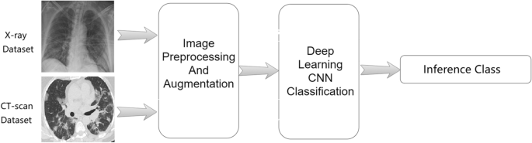

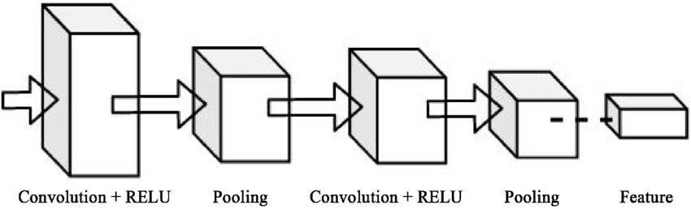

Block diagram for paper model :

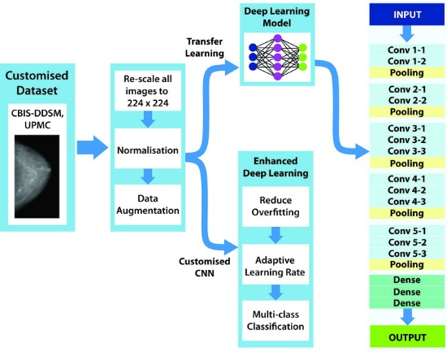

* **Our Model**

**18 layers (**4Conv, 4MaxPool,1 flatten,4 Dropout,4 hidden layer,1 Output layer **)**

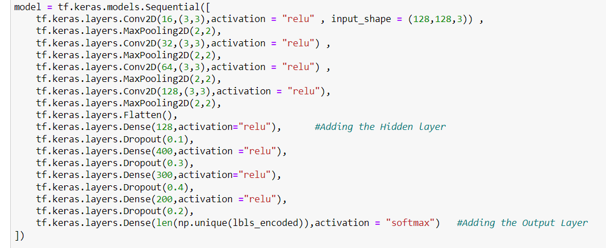

**Hyper parameters and architectures tested before reaching the final model**

optimizer='adamax',

loss='categorical_crossentropy',

metrics = ['acc']

epochs=20

**our model before editing :**

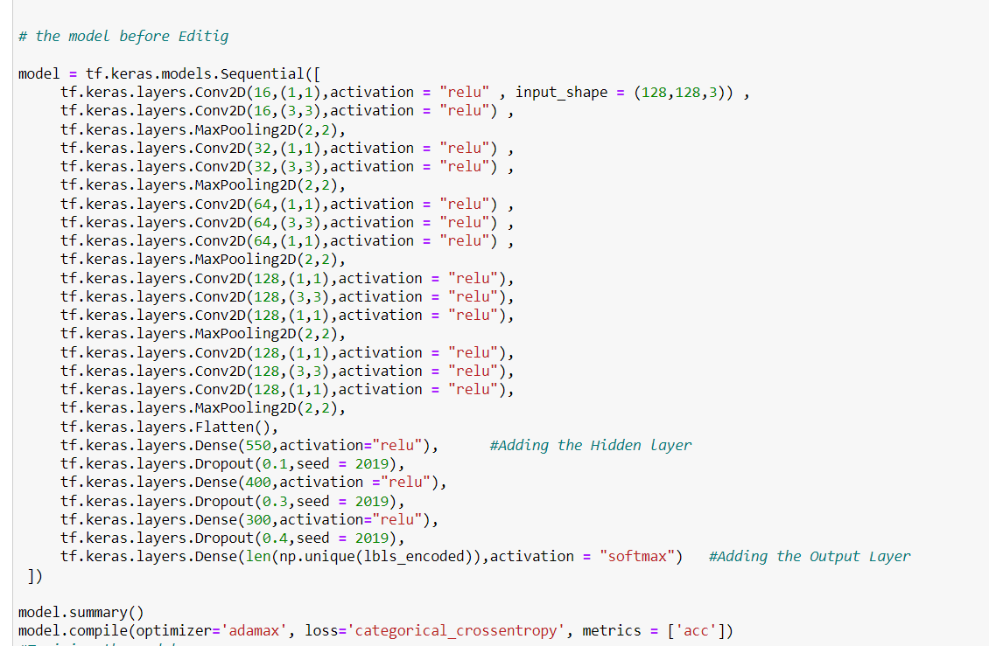

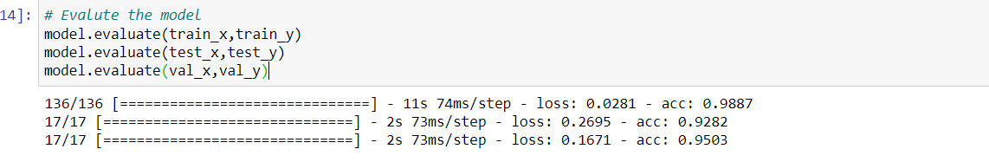

**Our accuracy before Editing:**

**Acc train:**0.988

**Test acc:** 0.928

**Validation acc:**0.95

**our model after editing:**



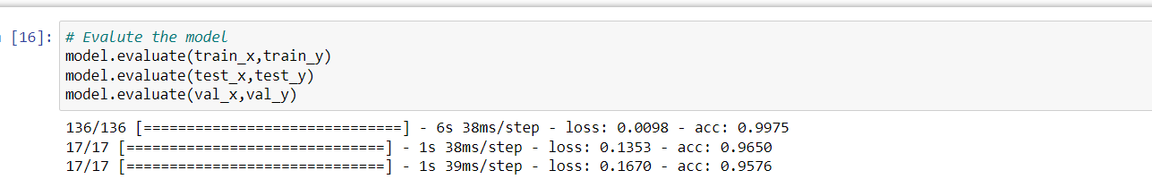

**Our accuracy After Editing:**

**ACC train:** 0.99

**Test ACC:** 0.97

**Validation ACC :** 0.96

**Training and validation loss an accuracy :**

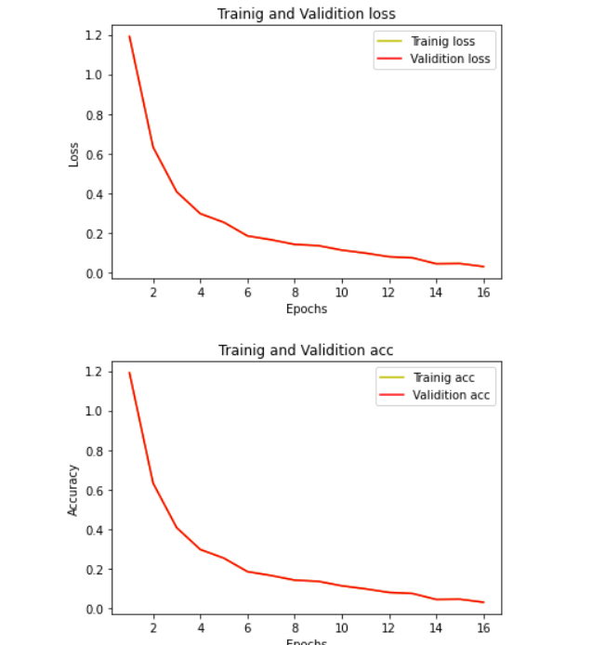

**Confusion matrix:**

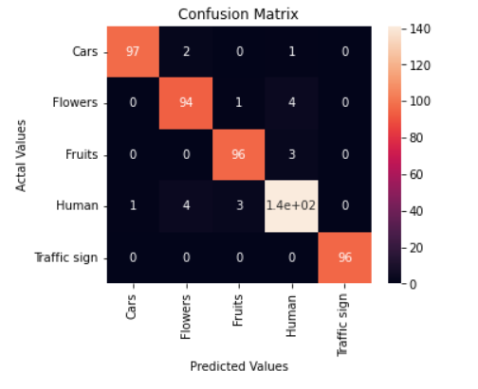

**Roc Curve :**

